**ARIGNAR ANNA GOVERNMENT ARTS COLLEGE, MUSIRI.**

**Affiliated to Bharathidasan University, Tiruchirappalli.**

**NAAN MUDHALVAN PROJECT – III BSC PHYSICS.**

**TOPIC FOR THE PROJECT:**

**Unlocking Insights into the Global Air Transportation Network.**

**SUBMITTED BY: TEAM THREE (3)**

* **TEAM ID: NM2023TMID25463**
* **TEAM LEADER:**

**GOKULRAJPOOVAN R: F98671EB2094725A11346E46204561F**

* **TEAM MEMBERS:**

**JEEVA C: 1C51512DE57CCBDBBB14B33430219C352**

**JOTHIKANNAN P: 460EFFB95B1B981A04948E05B650BCC1**

**KALAIYARASAN S: D8DF3C45016EEA6B24D433F878DF2FA1**

**INTRODUCTION:**

* Air transportation is the movement of passengers and goods by aircraft. It's an important part of the global economy, facilitating trade, tourism, and employment.
* The aviation industry is one of the fastest transportation sectors. It provides 87.7 million jobs worldwide.
* Global air transportation refers to the worldwide network of commercial and cargo aviation services that connect people and goods across the globe.
* It involves a complex system of airlines, airports, air traffic control, and supporting infrastructure to facilitate the movement of passengers and freight.
* The air transportation network is a complex network with the properties of small-world networks and scale-free networks.
* **MILESTONE 1: Define Problem / Problem Understanding.**
* **Activity 1:**

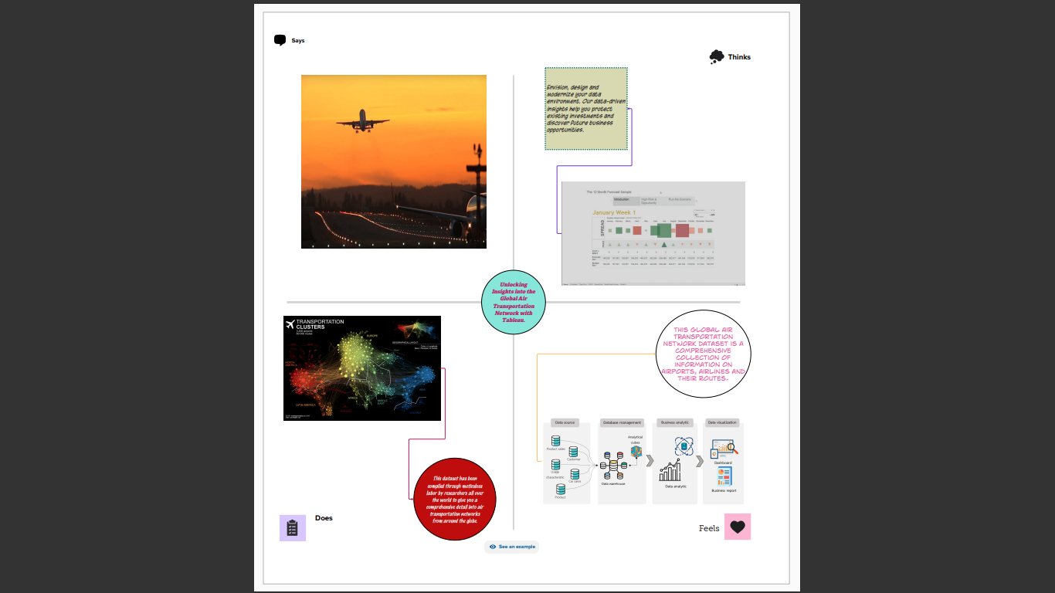

* **Activity 2: Requirement.**

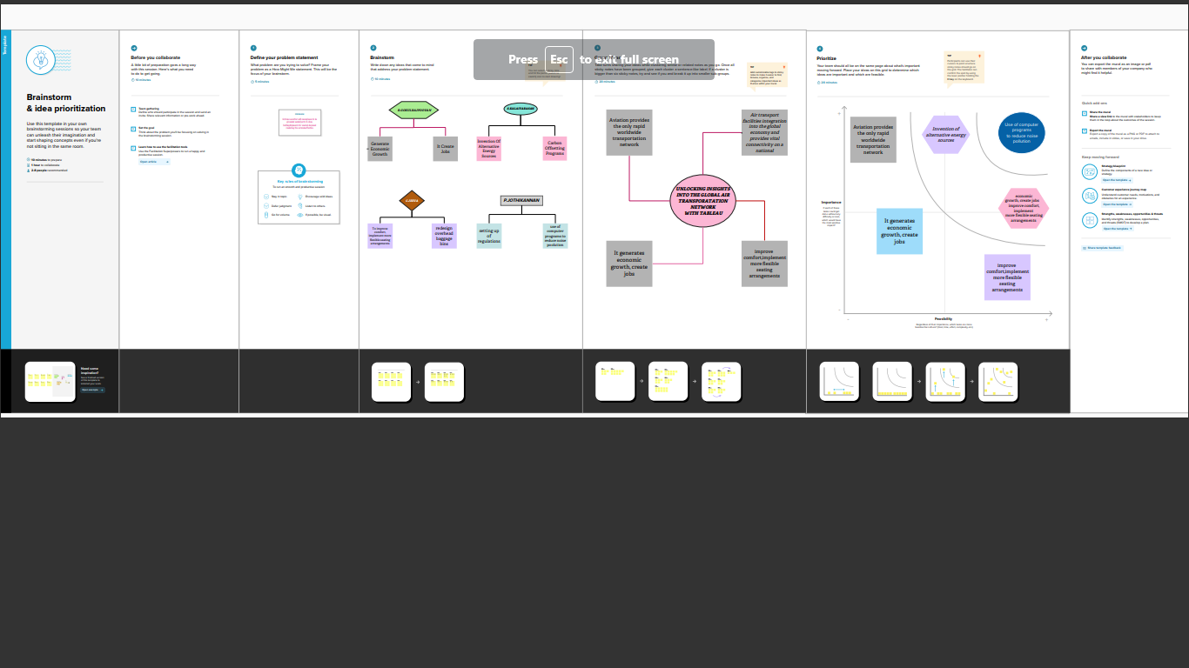

**REFERNCE:**

* Wensven, J.G.,AirTransportion:A Management Perspective, Ashgate, 2007.
* Belobaba,P.,Odoni,A.andBarnhart,C.,Global Airline Industry, Wiley,2009.
* M.Bazargan,M., Airline operations and Scheduling Ashgate, 2004.
* Nolan,M.s., Fundamentals of Air Traffic Control,fourthedn., Thomson Learning, 2004.
* Wells, A. and young, S.,Airport Planning and Management, fifth edn., McGraw-Hill, 1986.
* **MILESTONE 2: Data Collection & Extraction.**
* **Activity 1: Collect the Dataset.**

Please use the link to download the dataset:

<https://drive.google.com/drive/folders/1RJnbcGxvIVulM3fkZH1Wz3_IbLDP2RjY?u>

* 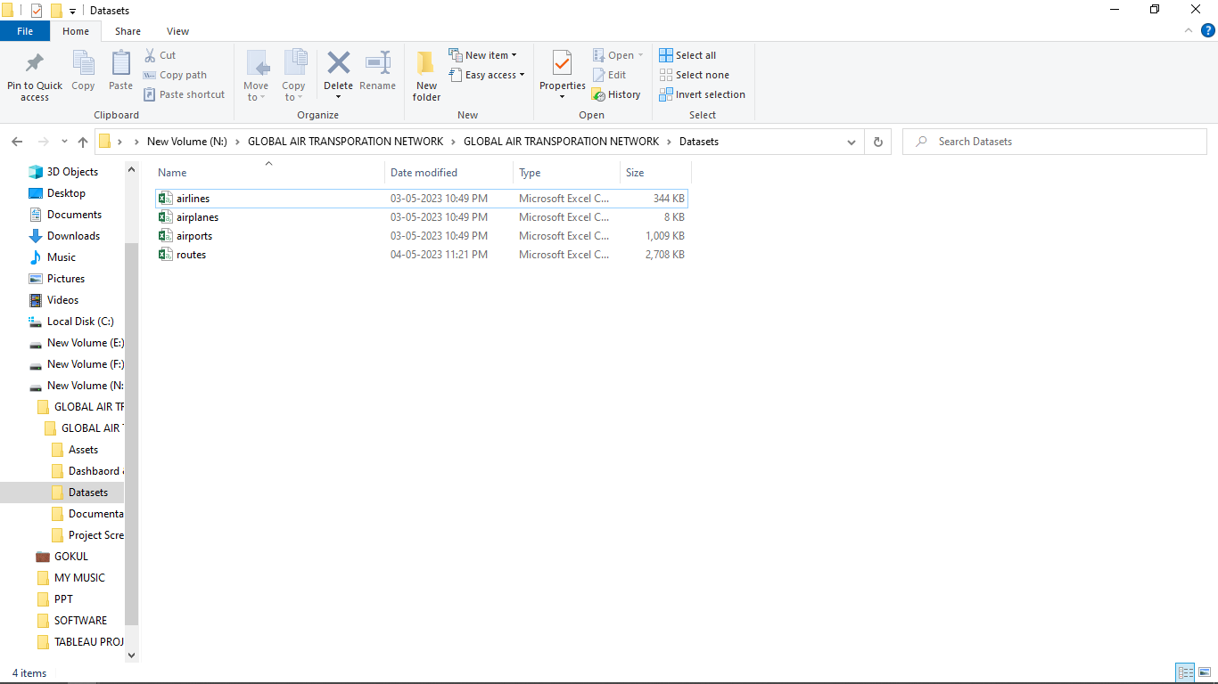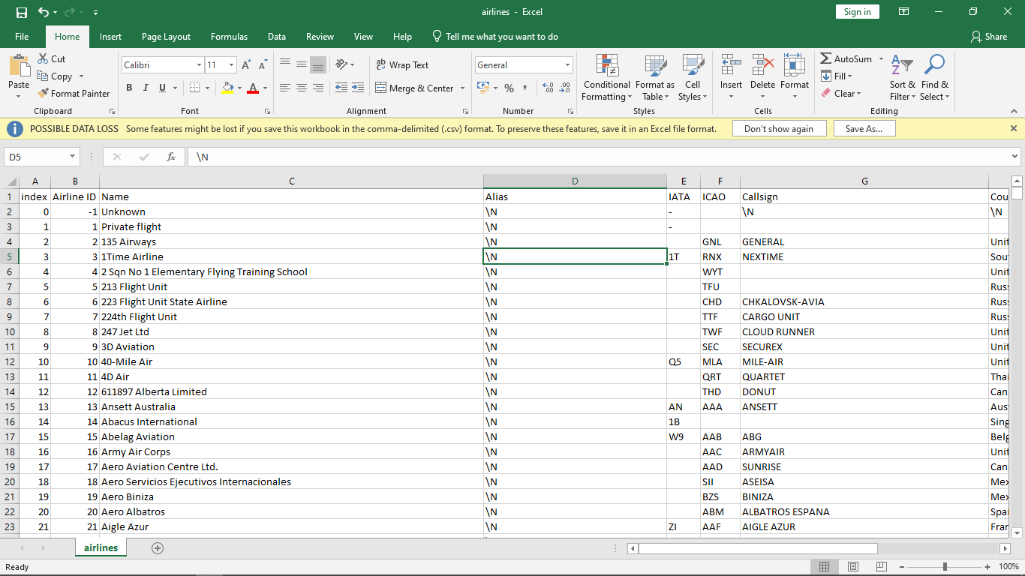**Activity 1.1: Understand the data.**
* 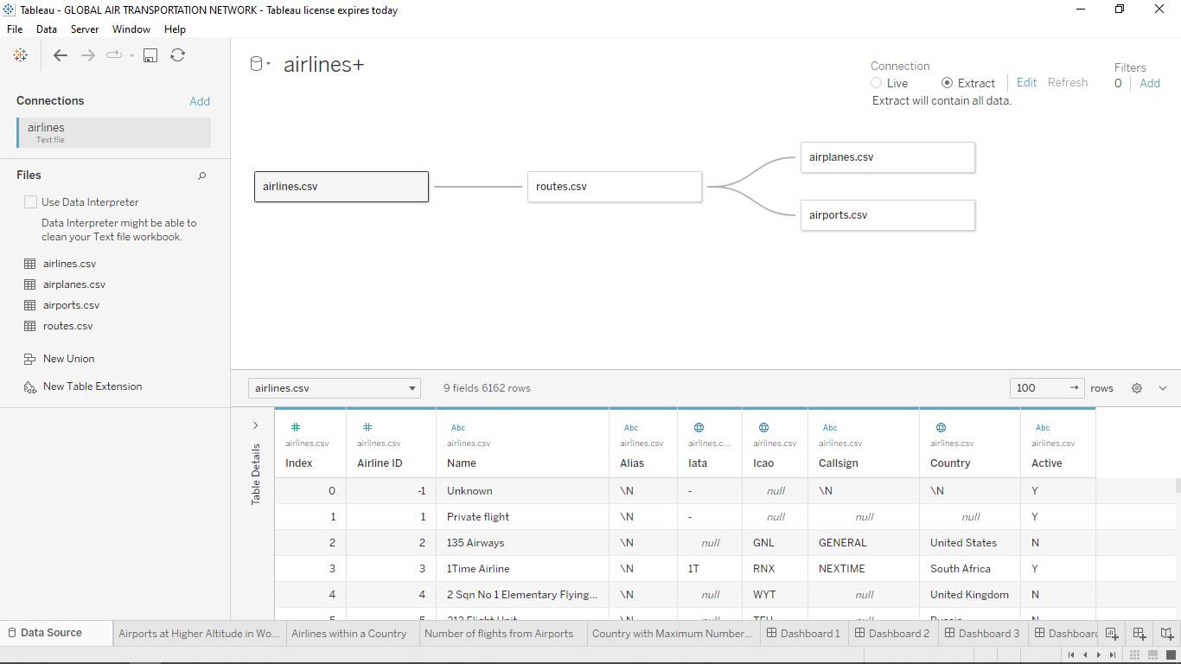**Activity 2: Connecting to Tableau.**
* **MILESTONE 3: Data Preparation.**

This process helps to make the data easily understandable and ready for creating visualization gain insights into performance and efficiency.

* **MILESTONE 4: Data Visualization.**

Data visualization is the process of creating graphical representations of data in order to help people understand and explore the information**.**

* **Activity 1: No. of Unique Visualization.**

The number of unique visualizations that can be created with a given dataset. These visualizations can be used to compare performance, track changes over time, and show distribution, and relationships between variables.

* **Activity 1.1: World Map Showing details of all Airports within a Country.**
* 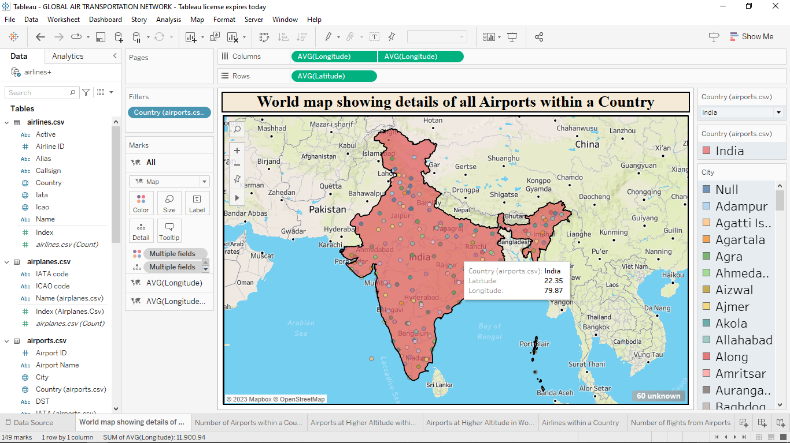**Activity 1.2: Number of Airports within a Country.**

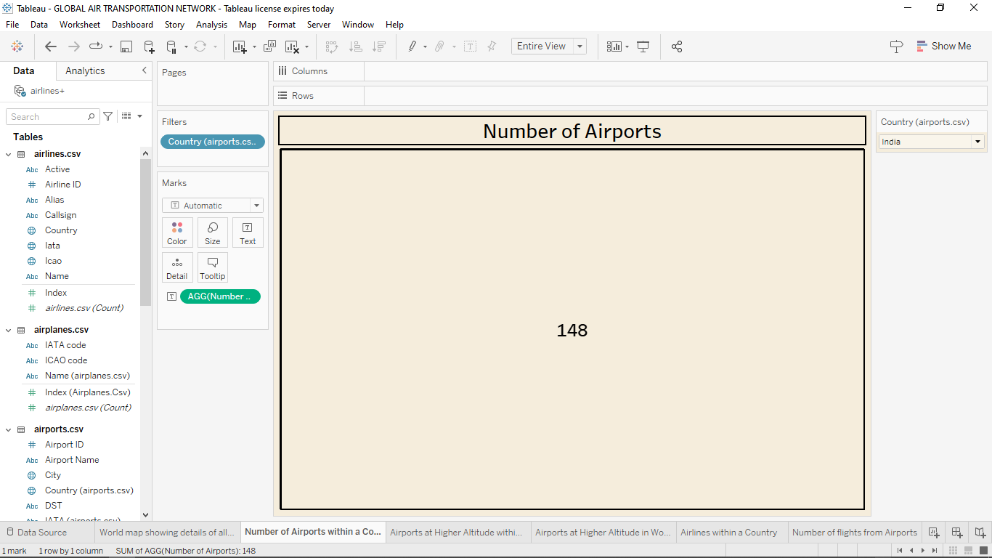

* **Activity 1.3: Airports at Higher Altitude within a Country.**

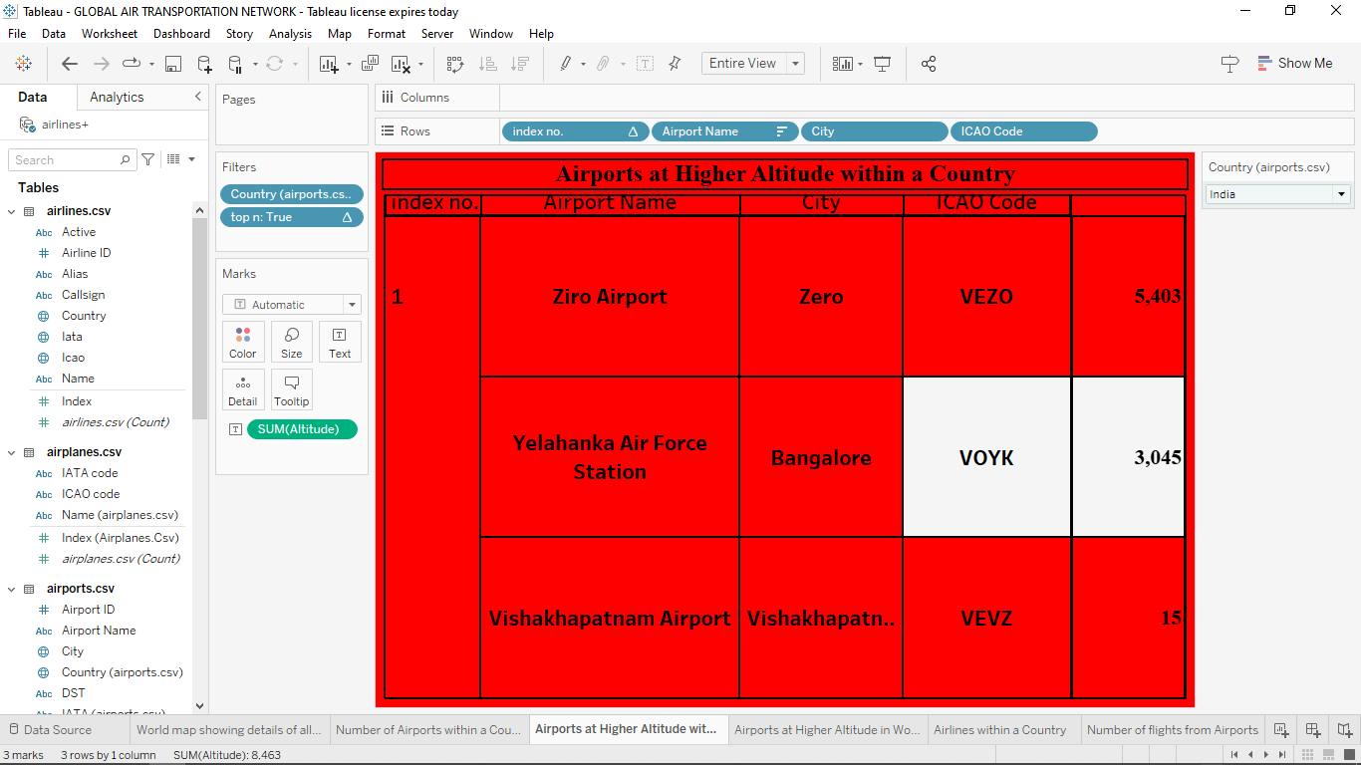

* **Activity 1.4: Airports at Higher Altitude in the World.**

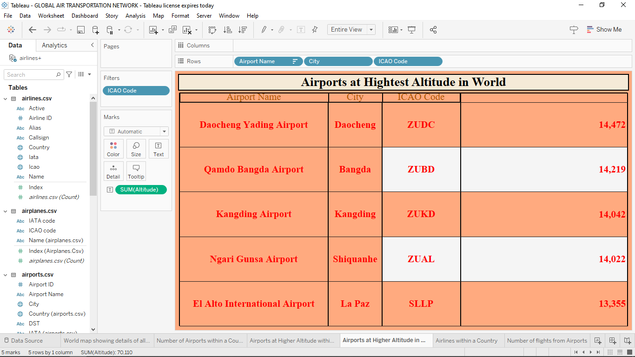

* **Activity 1.5: Airlines within a Country.**

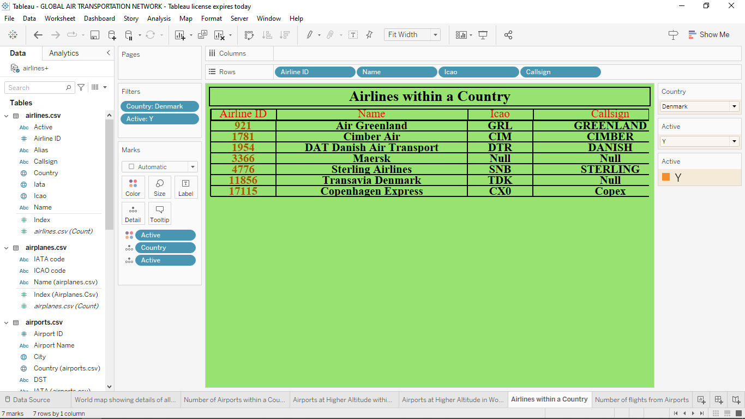

* **Activity 1.6: Number of Flights from Airports.**

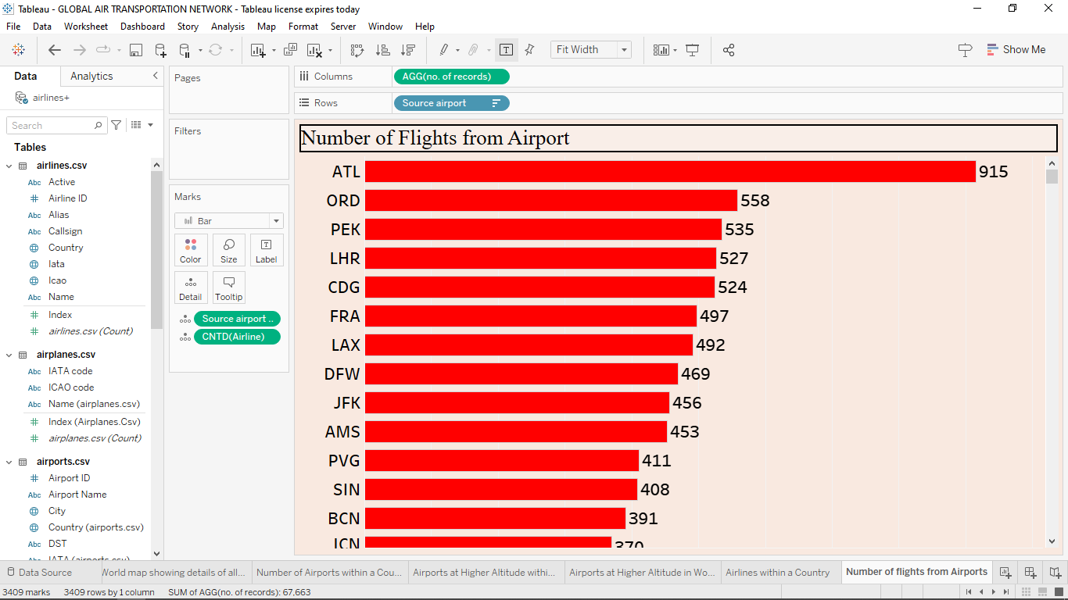

* **MILESTONE 5: Dashboard.**

A dashboard is a graphical user interface (GUI) that displays information and data in an organized, easy-to-read format.

* **Activity 1: Responsive & Design of Dashboard.**

The goal is to create a dashboard that is user-friendly, interactive, and data-driven, providing actionable insights.

* **DASHBOARD 1:**

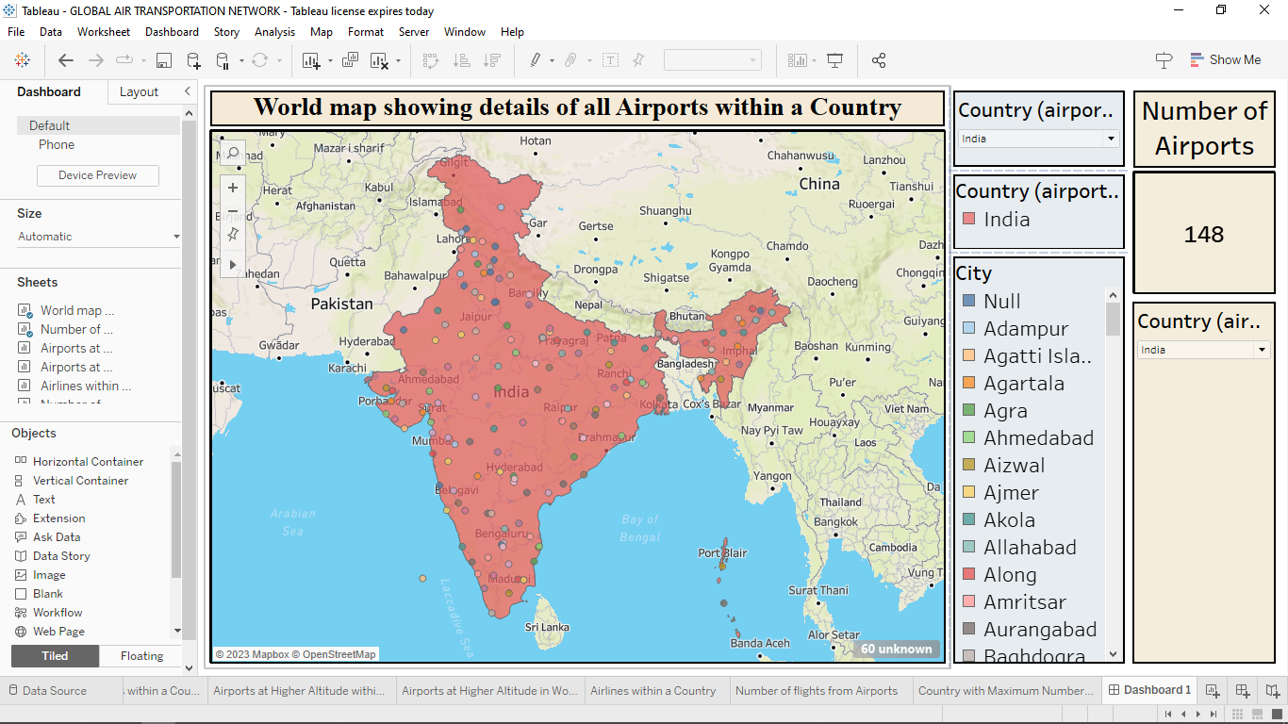

* **DASHBOARD 2:**

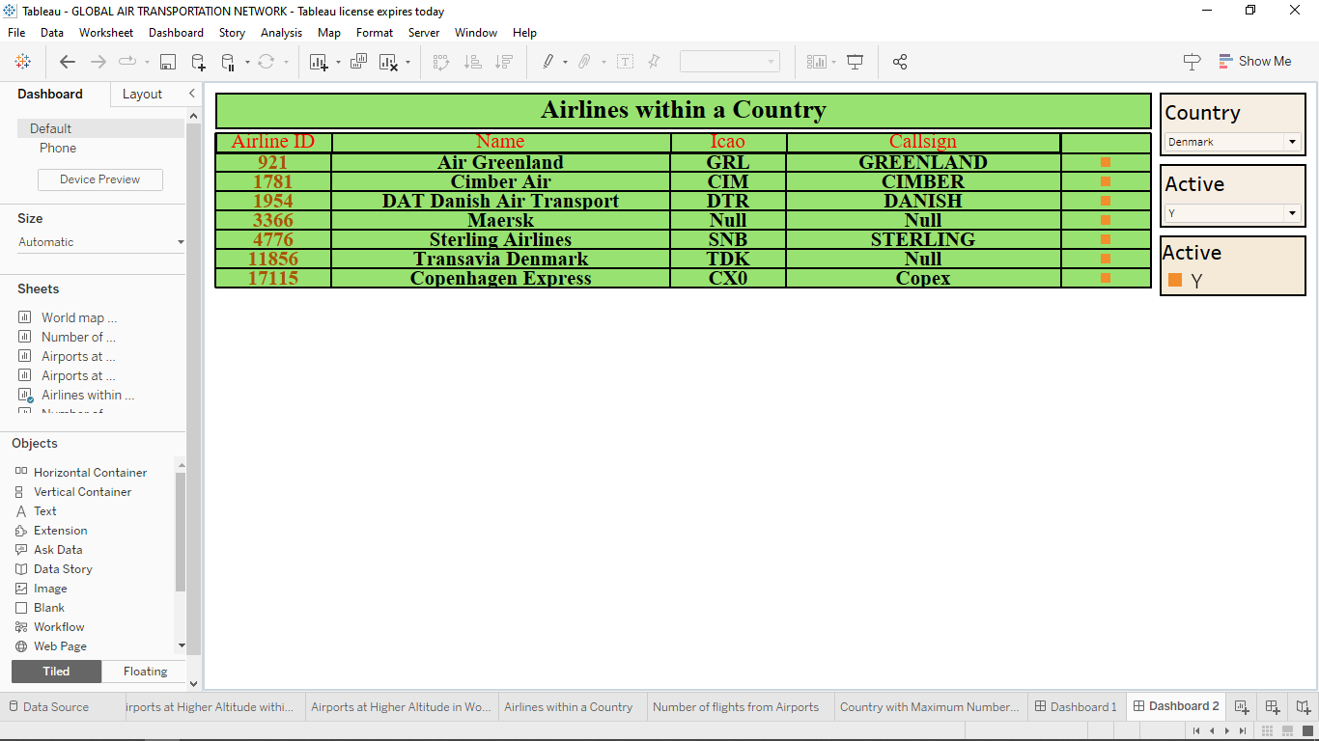

* 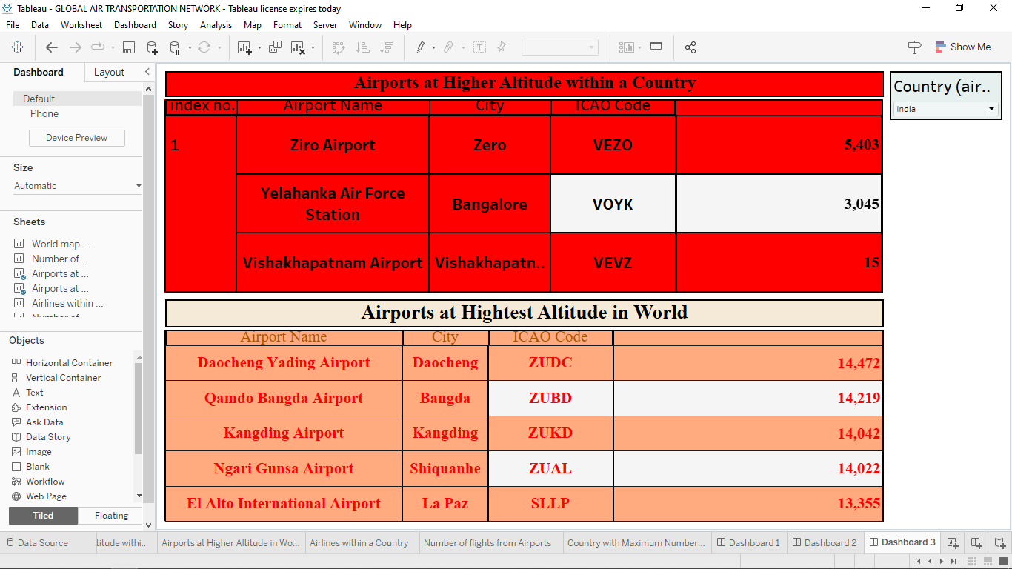**DASHBOARD 3:**
* **DASHBOARD 4:**

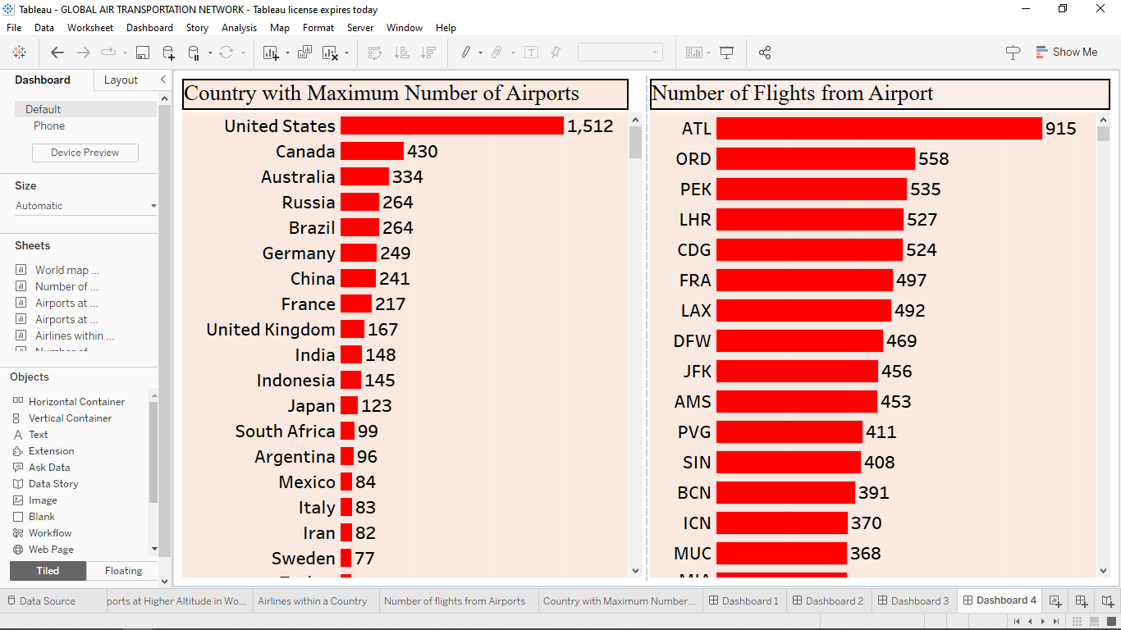

* **MILESTONE 6: Story.**

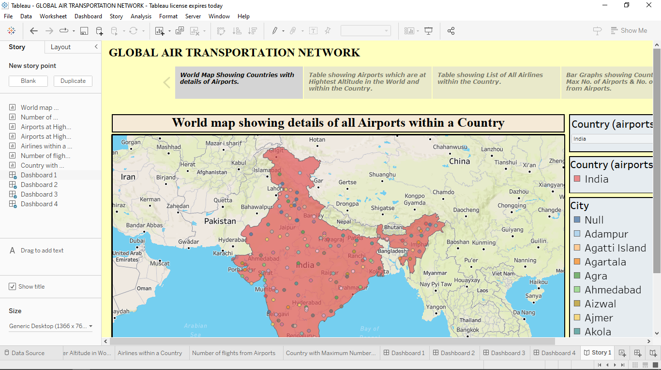 A data story is a way of presenting data and analysis in a narrative format, with the goal of making the information more engaging and easier to understand.

* **MILESTONE 7: Publishing.**

Publishing helps us to track and monitor key performance metrics, to communicate results and progress. help a publisher stay informed, make better decisions, and communicate their performance to others.

* **DASHBOARD 1:**

<https://public.tableau.com/views/GLOBALAIRTRANSPORTATIONNETWORK/Dashboard1?:language=en-US&publish=yes&:display_count=n&:origin=viz_share_link>

* **DASHBOARD 2:**

<https://public.tableau.com/views/GLOBALAIRTRANSPORTATIONNETWORK-DASHBOARD2/Dashboard2?:language=en-US&publish=yes&:display_count=n&:origin=viz_share_link>

* **DASHBOARD 3:**

<https://public.tableau.com/views/GLOBALAIRTRANSPORTATIONNETWORK-DASHBOARD3/Dashboard3?:language=en-US&publish=yes&:display_count=n&:origin=viz_share_link>

* **DASHBOARD 4:**

<https://public.tableau.com/views/GLOBALAIRTRANSPORTATIONNETWORK-DASHBOARD4/Dashboard4?:language=en-US&publish=yes&:display_count=n&:origin=viz_share_link>

* **STORY:**

<https://public.tableau.com/views/GLOBALAIRTRANSPORTATIONNETWORK/Story1?:language=en-US&publish=yes&:display_count=n&:origin=viz_share_link>

* **CONCLUSION:**
* The 21st century has seen the continued internationalization and globalization of the world’s economy. There is also evidence of deeper globalization of cultures and politics.
* Air transport is a facilitator and, as such, the demands for its services are derived from the requirements for high-quality, speedy, and reliable international transport.
* Globalization, almost by definition, means demands for greater mobility and access, but these demands are for different types of passengers and cargoes, to different places, and over different distances than was the previous norm.
* International air transport is less than a century old, but is now a major contributor to globalization and is continually reshaping itself to meet the demands of the economic and social integration that globalization engenders.
* Economically, in static terms, globalization occurs to facilitate the greater division of labor and allows countries to exploit their comparative advantage more completely.